|  |  |  |  |  |  |
| --- | --- | --- | --- | --- | --- |
| Mata Kuliah | : | Sinyal dan Sistem | Waktu | : | 120 Menit |
| Kredit | : | 3 sks | Hari/Tanggal | : | Senin / 14-04-2021 |
| Nama Dosen | : | Mifta Nur Farid, S.T., M.T.  Risty Jayanti Yuniar, ST., M.T. | Sifat | : | *Open book* |

1. Given that

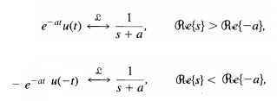

Determine the invers Laplace transform of

$$X(s)=\frac{2(s+2)}{s^{2}+7s+12}$$

-4 < *Re(s)* < -3

Score: 20

1. Consider a causal LTI system with impulse response *h(t)= (3e-2t+4e-t) u(t)*
2. Determine the Laplace transform of *h(t)*.
3. Determine a differential equation relating *y(t)* and *x(t).*
4. Sketch the pole-zero pattern of *H(s)*
5. Create a block diagram representation of *S.*
6. Is this system stable?

Score: 50

1. Consider a causal LTI system whose input *x[n]* and output *y[n]* are related through the block diagram representation shown in Figure 1.

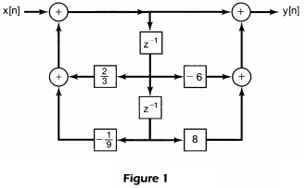

1. Determine a difference equation relating *y[n]* and *x[n].*
2. Determine *H(z)*.
3. Is this system stable?

Score: 30

*------- “” Life is like riding a bicyle. To keep your balance, you must keep moving*

*– Albert Einstein------*